**SAMPLING METHODS AND SAMPLE SIZE CALCULATIONS BASED ON RESEARCH DESIGN**

1. **Sampling Methods**

Sampling methods are broadly categorized into probability and non-probability sampling.

**(A) Probability Sampling (Random Sampling)**

Every individual in the population has a known chance of being selected.

* **Simple Random Sampling (SRS)** – Each subject is chosen randomly, ensuring equal probability.
* **Systematic Sampling** – Every nth individual is selected after a random start.
* **Stratified Sampling** – The population is divided into subgroups (strata), and participants are randomly selected from each stratum.
* **Cluster Sampling** – The population is divided into clusters, and entire clusters are randomly selected.
* **Multistage Sampling** – A combination of different probability sampling techniques.

**(B) Non-Probability Sampling (Non-Random Sampling)**

Selection is based on researcher judgment, convenience, or accessibility.

* **Convenience Sampling** – Participants are selected based on availability.
* **Purposive Sampling** – Participants are selected based on specific criteria relevant to the study.
* **Snowball Sampling** – Existing participants recruit new participants, commonly used for hard-to-reach populations.
* **Quota Sampling** – The researcher ensures a certain proportion of different subgroups in the sample.

1. **Sample Size Calculations Based on Research Design**

Sample size is calculated to ensure statistical power and precision in estimating effects. Below are sample size considerations for different study designs.

1. **Cross-Sectional Studies**

Used to assess prevalence or associations at a single time point.

**Formula for proportion-based studies:**

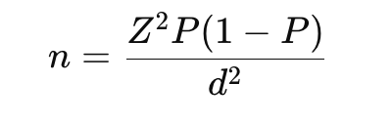

Where:

* + n = required sample size
  + Z = Z-score (1.96 for 95% confidence level)
  + P = estimated proportion in the population
  + d = margin of error

If comparing two proportions:

Where:

* + P1, P2 = expected proportions in each group
  + Z_{\alpha/2} = Z-score for confidence level
  + Z_{\beta} = Z-score for statistical power

1. **Case-Control Studies**

Used for studying associations between exposure and outcomes.

Sample size depends on the expected odds ratio (OR) and proportion of exposure in controls.

**Formula:**

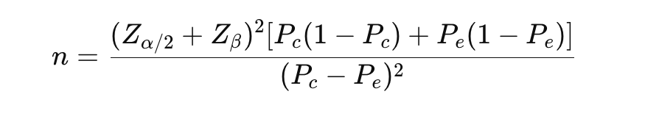

Where:

* P_c = proportion of exposure in controls
* P_e = proportion of exposure in cases

1. **Cohort Studies**

Used to measure incidence rates and risk factors over time.

**Formula:**

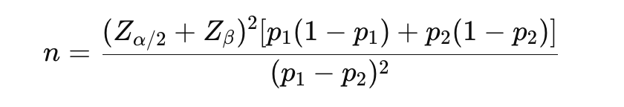

Where:

* p1, p2 = expected incidence rates in exposed and unexposed groups.

1. **Randomized Controlled Trials (RCTs)**

Used to assess treatment effects.

**Formula:**

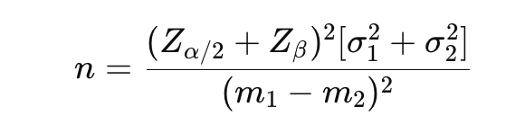

Where:

* σ1, σ2 = standard deviations in the two groups
* m1, m2 = mean outcomes in each group

**Summary Table of Sampling and Sample Size by Research Design**

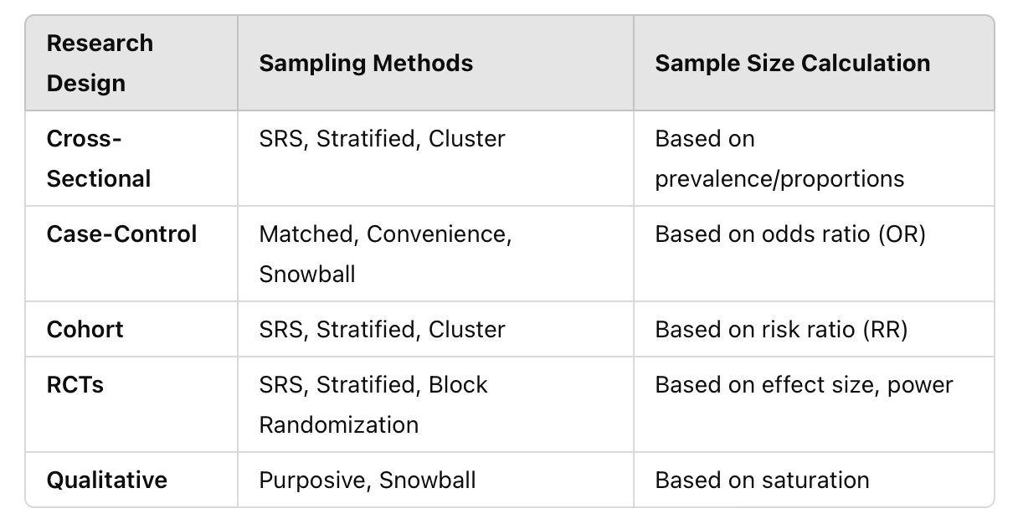

**Important:**

* The best sampling method depends on study objectives, population characteristics, and feasibility.
* Sample size should balance statistical power, precision, and resource constraints.
* Statistical software like Stata and R can assist in sample size calculations.